**Sprint 3 Plan**

Product Name: Toss Time

Team Name: Sinked Inc.

Completion Date: Nov. 16th, 2021

**Goal**:

To produce a prototype which utilizes a combination of UI and Database Systems.

**Task Listing**

“As a dye player, I want to see if a house has good house rules so that I would enjoy playing there.”

☐ Task B3: Establish a working database implementation ( 6 hours )

☐ Task B4: Look into adding images to UI ( 5 hours )

☐ Task B5: Create a UI button that allows you to create a table profile ( 4 hours )

☐ Task B6: Connect database field for table profiles with application files ( 4 hours )

☐ Task B7: Link table profile to a marker on the map ( 5 hours )

☐ Task B8: Create UI pop-up for creating a table profile ( 6 hours )

☐ Task B9: Load markers from database when app starts ( 4 hours )

☐ Task B10: UI Login Page using email & password with database ( 6 hours )

“As a dye player, I want to see other players' stats and show off my own so that I can find players who are at my skill level.”

☐ Task C1: Add some class into the database for tournaments ( 3 hours )

**Team Roles & Initial Task Assignments**

Cole Hennig - Product Owner - Tasks B4, B5

Ryan Ahrari - Scrum Master - Tasks B3, B6

Anton Kozintsev - Team Member - Tasks B4, B7, B8, B10

Kenny Blum - Team Member - Tasks B3, B6, B9

Steve Beurard - Team Member - Tasks B3, B6

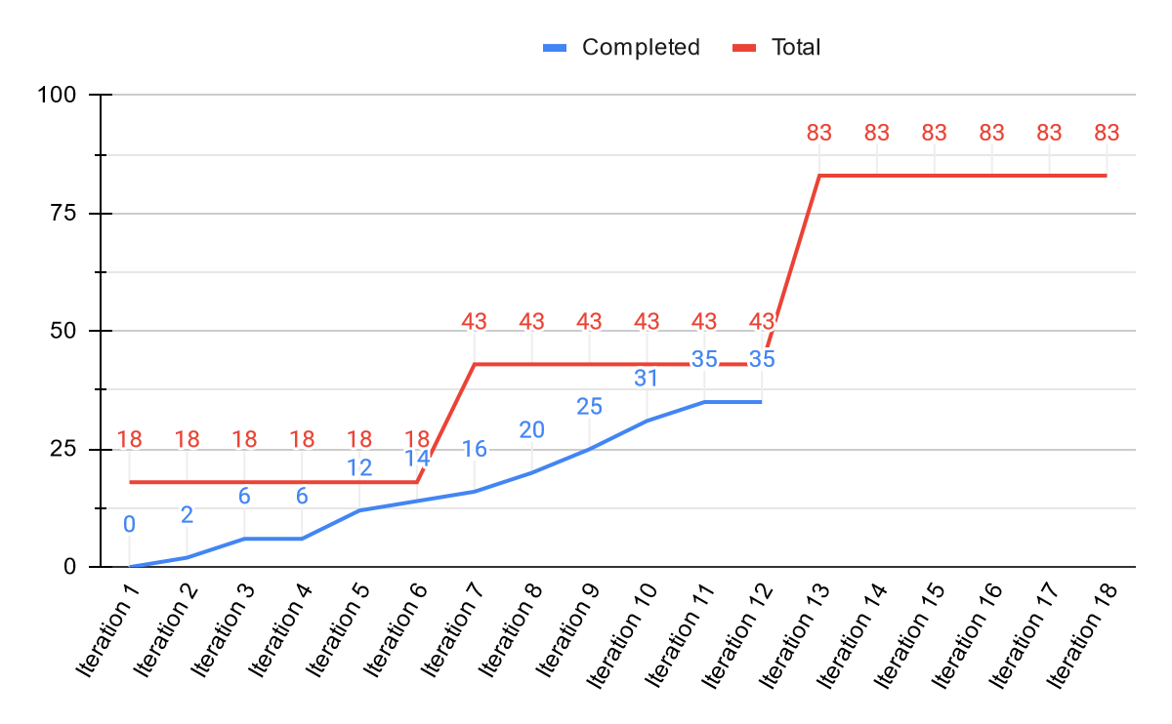

**Sprint 3 Initial Burn-Up Chart**

**Initial Scrum Board**

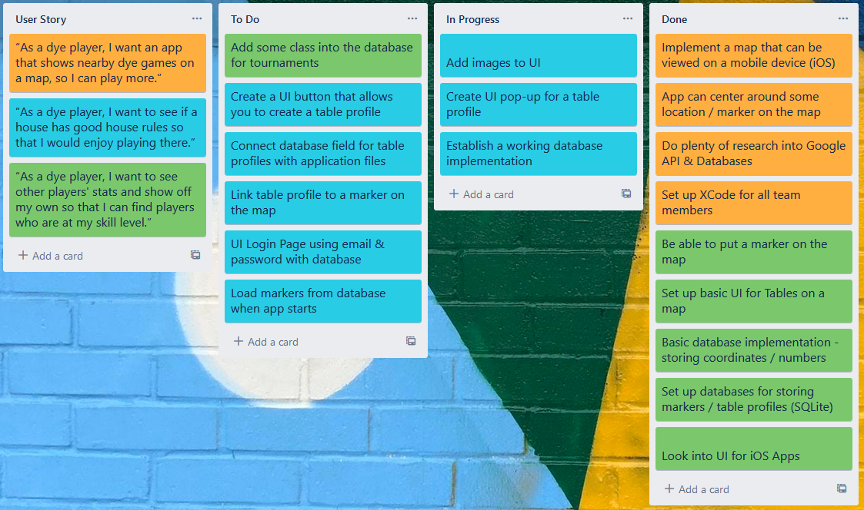

**Scrum Times**: Monday / Wednesday / Friday @ 2:30PM